**Kent Active Part 5 Issue 88**

**…and just when you thought that there could not possibly be more bowling – suddenly MORE BOWLING!**

**../10%20Pin%20Bowling%20Comp%202022/10%20Pin%20Doc%202022%20v2%20198%20Ian%20Procter%20CliffARA.pdf**

**BarnARA**

***(Bexleyheath and Barnehurst ARA)***

**On the 14th July, 100 Barnara members were delighted to welcome KentAra Chairlady, Mrs Joan Rhodes and her husband Les, as ‘Guests of Honour’, as we came together to celebrate our 21st birthday, and the Queen’s Platinum Jubilee.**

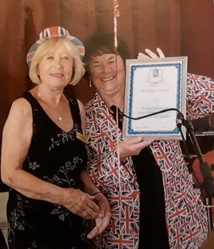

**Mrs Rhodes presented our Chair. Mrs Barbara Sampson with a 21st Birthday Certificate and congratulated us on the success of the Club.**

**Many of our members had worked hard to decorate the Hall, and during the afternoon we enjoyed a delicious Cream Tea whilst listening to some patriotic music, and ended the afternoon with a rousing sing-song.**

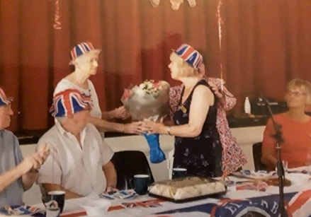

**We are pleased to report that Barnara is almost back to normal after the last couple of years of lockdown. We average 110 members at our monthly meetings, and we are enjoying some good days out and various events at St. Martin’s Hall.**

**We are looking forward to our annual Christmas lunch which is held at ‘The Boathouse’ in Danson Park, where we have enjoyed lovely food, and a beautifully decorated restaurant for the last two Christmases.**

**Pamela Chapman. Secretary, Barnara.**

**Please send your Club pictures, and news stories to the KentARA website via our Webmistress Pat Cox at pmc1948@live.co.uk**

**The KentARA website.** [**https://kentara.weebly.com**](https://kentara.weebly.com)

**Please ensure that all pictures you send have the permission of those who appear in them, to be published.**

**Words of Comfort**

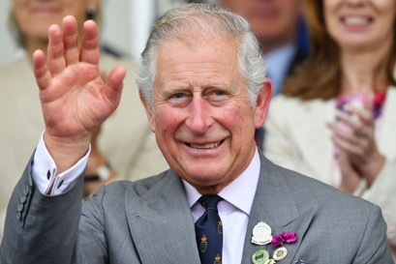

**GSTK**

***Jesus said unto her, “I am the resurrection and the life.***

***Whoever believes in me, though they die, yet shall they live”.***

**John 11 v25.**

**DATES FOR THE DIARY**

**2022**

* **Race Afternoon with Afternoon Tea**

**Ditton Community Centre**

**Thursday 20th October 2022**

**1.30pm - 6pm**

* **10 Pin Bowling Tournament 2022**

**Thursday 3rd November**

**Hollywood Bowl, Rochester. ME2 2SS**

* **KentARA Tea Dance – *Just too good to miss…***

**Friday 11th November 2022 1.30pm – 5pm**

**Ditton Community Centre / Ballroom 01732 870 715**

* **KentARA Christmas Concert**

**at Ditton Community Centre**

**Thursday 8th December/ 1.30pm – 6pm**

**Attended by Tracey Crouch MP (our new President) &**

**The Mayor of Tonbridge and Malling, Mrs. Sue Bell.**

* **Short Mat Bowls at Ditton. August 2023**

**(TBC)**

* **‘KentARA Quiz’ at Ditton. 2023 (TBC)**
* **KentARA AGM at Ditton. 2023**

**(TBC) 10am Coffee / 11am Start**

**&**

* **Line Dancing EVERY MONDAY Afternoon**

**Larkfield Village Hall. 12 noon to 3.45pm**

**All Levels. Enquiries, Gerald Benham 01732 870 715**



**kentarA**

PROUDLY PRESENTS

**A TEA dance**

**DITTON COMMUNITY CENTRE**

DANCING TO STEPHENS MUSIC

**FRIDAY the 11th of November**

**1.30 FOR 2PM START FINISHES AT 5PM**

**ENTRANCE ONLY BY TICKET**

**COST £6 TO INCLUDE TEA, CAKES**

**& PLENTY OF COLD DRINKS**

 **CONTACT: Gerald Benham** 

**01732 870 715**

***just too good to miss***



**Line Dancing**

FOR   
THE   
OVER 50’s

## WITH THE

### KENT ACTIVE RETIREMENT

#### **ASSOCIATION**

##### JOIN US AT

###### **Larkfield Village Hall**

New Hythe Lane

###### **EVERY MONDAY**

**(Except bank holidays)**

**Beginners Class - Monday 12pm**

**Easy Class - Monday starts 1pm**

**Advance Class - Monday 2pm to 3.45pm**

Enquiries tel. Gerald 01732 870 715

Just turn up and join in the fun!

**Help fund the opening of new Active**

**Retirement Clubs in Kent**

***No line dancing on Red and Amber Heat Alerts***

**A Word from William Wormshill**

**Worm Castle, Wormshill, Kent. WR0 3EY**

[**earthworks@lawn.co.uk**](mailto:earthworks@lawn.co.uk)

**Invest in a new Hot Water Bottle –**

***while you can still get one!***

**Why not go wild, get two, one for each foot.**

**Don’t wait for your old Hot Water bottle to perish on you, just when you need it most.**

**A Hot Tip.**

**To keep your Hot Water bottle warmer for an extra hour, stuff a sock in between the hot water bottle stopper, and fold the sock-top over it. Wrap the Hot Water bottle in a pillow case, if it does not come with a furry cover. (see pic).**

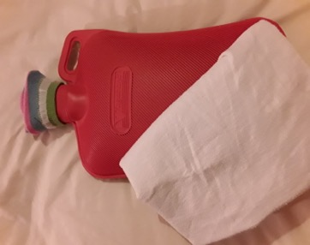

**This Hot Water bottle is a ‘Vagabond’ extra-large 2.7 litre;**

**it may cost you £5 to fill it, but it’s better than hypothermia.**

**Gladys Forsythe**

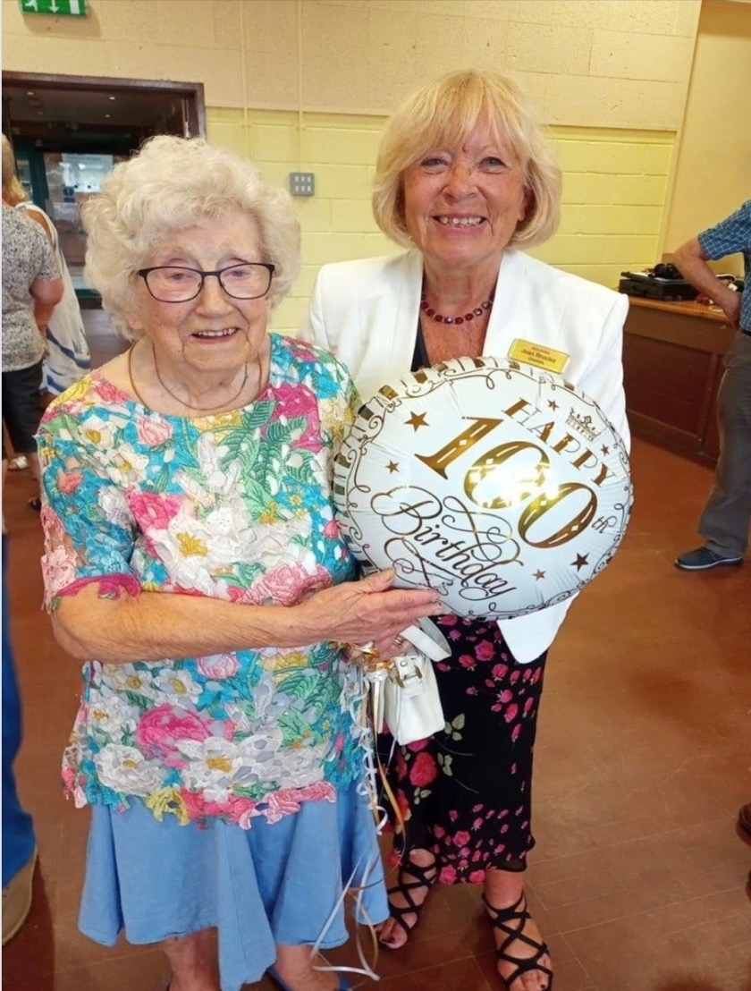

**In 1984 Gladys Forsythe saw an advert from Kentara asking people to start up clubs for retired people. She built up the club so much that she had to start a second in South Ashford. Once that got established she came back to AARA where she did several posts ending up in 2019 as the Welfare officer. If it hadn't been for her there would not have been a retirement club in Ashford. We at AARA wish Gladys a very Happy 100th Birthday & thank you for all you have done over the years.**