Kent Active Part 4 Issue 88
Short Mat ‘Knock Us-Out’ Bowls- Ditton. 25th August 2022

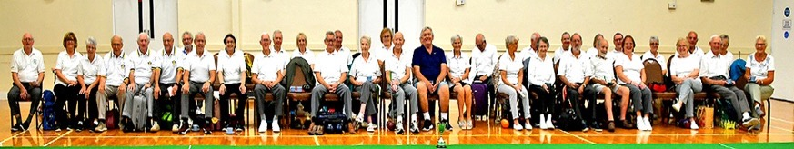
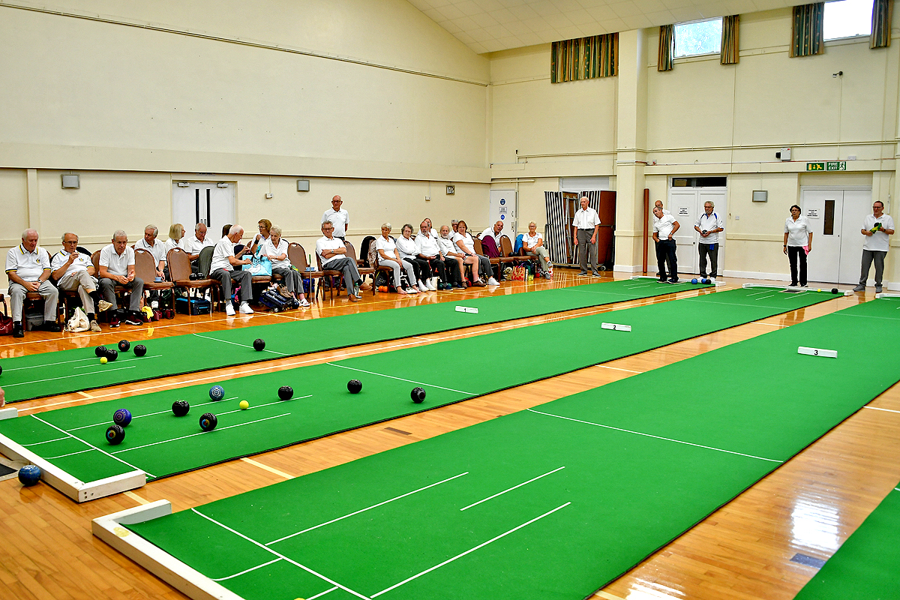
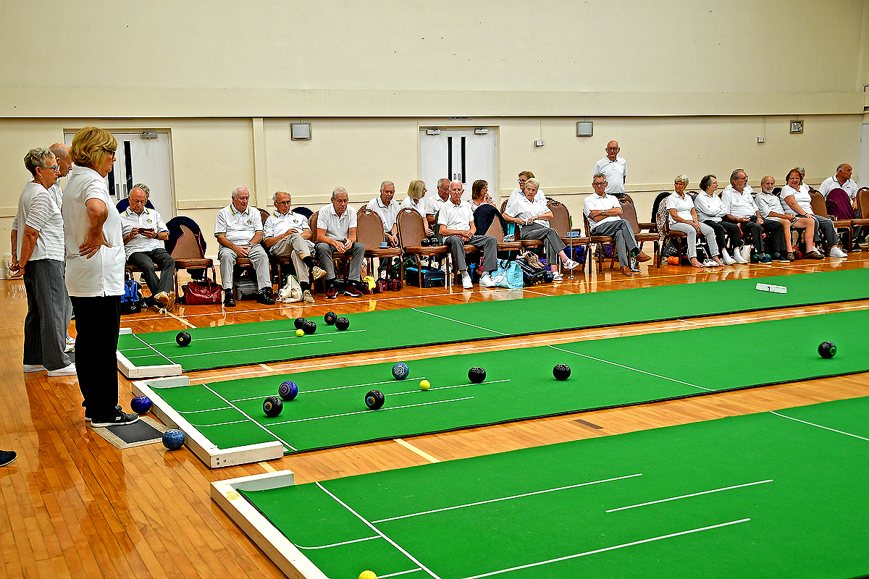
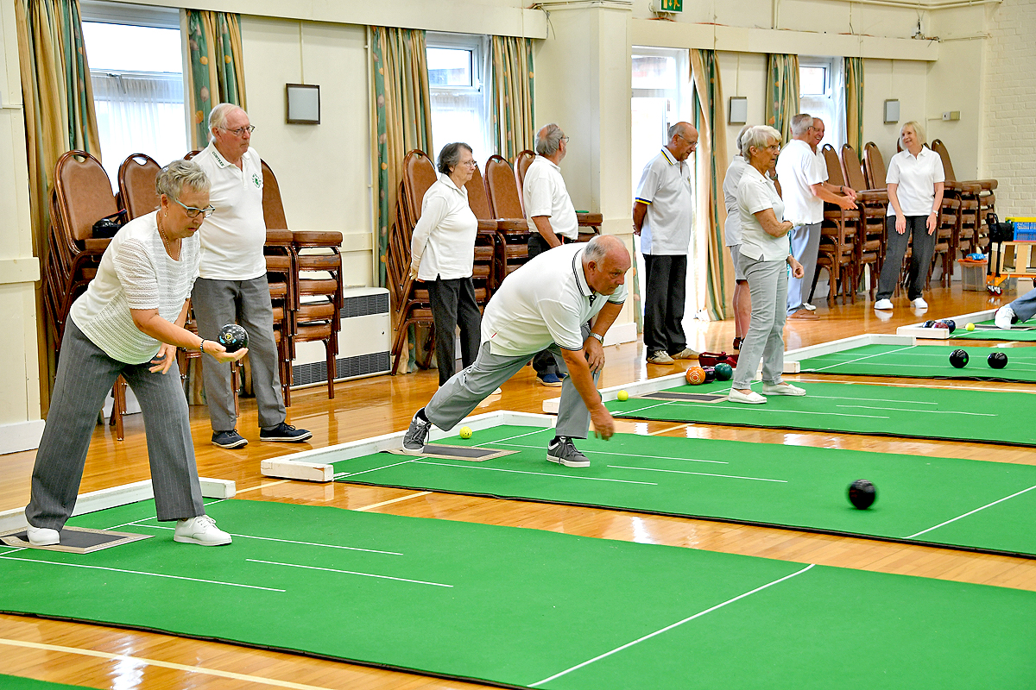

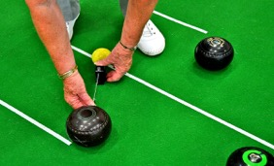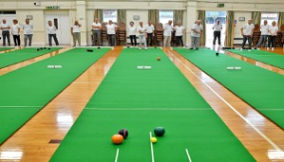

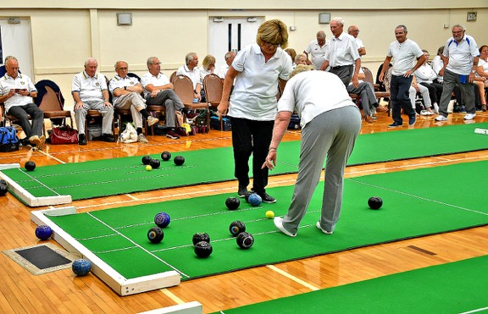

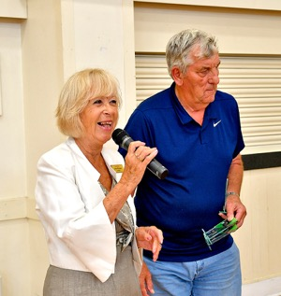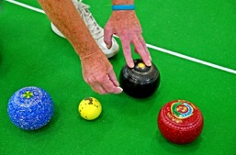

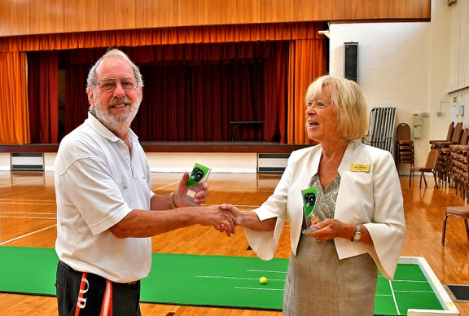
Climate activist glues himself to Joan Roads

August saw the KentARA Bowls competition resume after missing two years. Although numbers were a little lower, a hotly contested competition took place. Our Master of ceremonies, Dave Finch, kept things rolling along.

Joan unglued with the help of a friend…

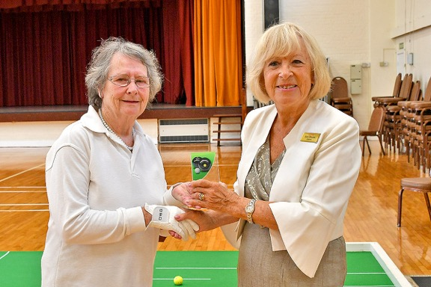
The Royal White Gauntlet
Thirteen teams entered for the chance of winning the Cup. Out of all the teams that took part, it went down to the last 2 teams to fight it out to take the cup home, and then host the event next year.

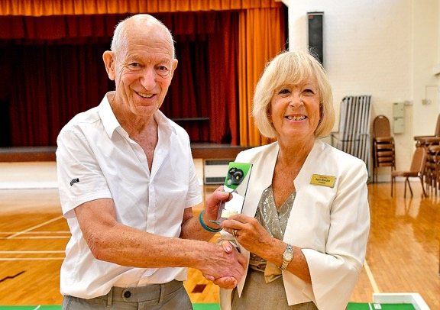
Head bowler

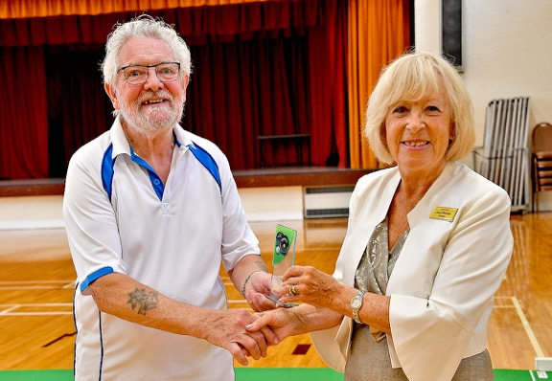
Prize for the best tattoos
A great day was had by all which started at 9.30am and went on to midnight. We expect there will be even more teams entering in 2023, so get planning now!

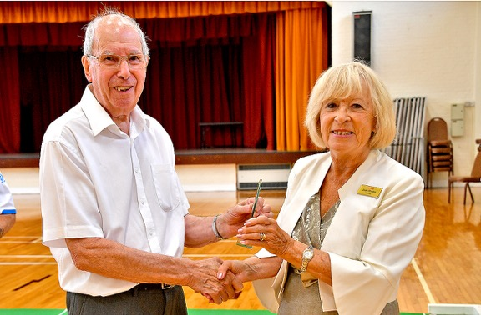
Joan hands bemused bowler ‘The Green Bic Pen’ prize

They can’t believe their luck! It was the magnets…
Dave Finch, kept things rolling along. The final was contested between HADara and BEara, with BEara the winners of the competition for 2022. We look forward to seeing you in 2023!
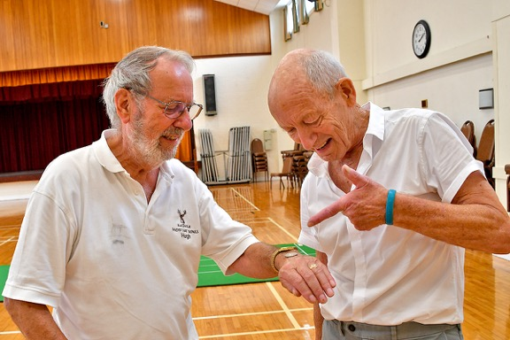
The double-sided coin wins again.

Regards, Bob Abnett.

