Kent Active Part 3 Issue 88
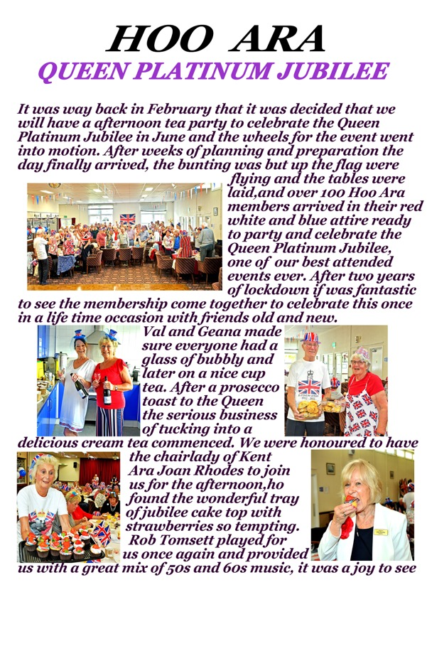

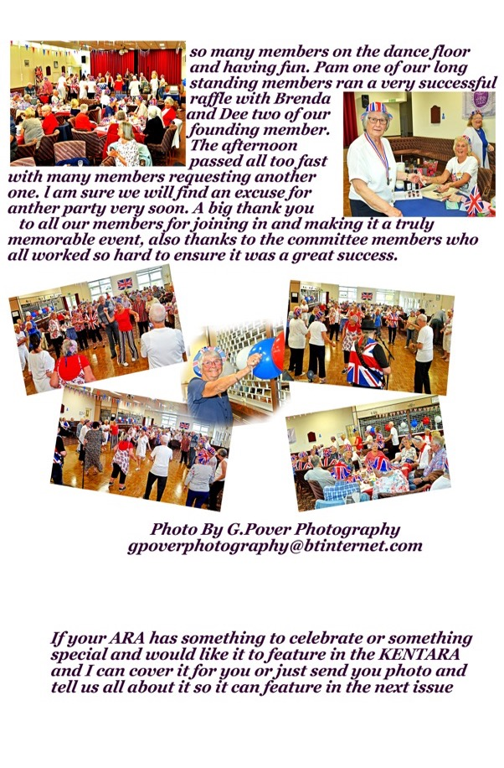

Goodbye to Old Shep
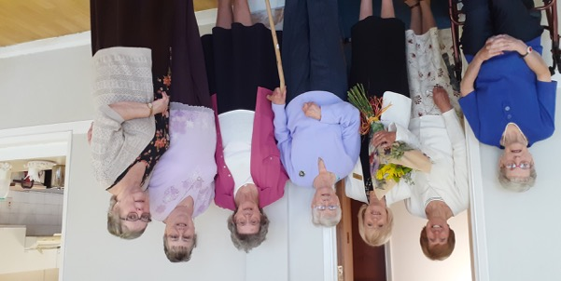

A sad farewell to Chairlady Eileen Holden of ShepARA Club with her committee, after 30 years of dogged service to the local community.
Thank you for all you’ve done for so many people.

The 2022 AGM
No one could hear a thing, but it didn’t matter anyway, because the fantastic free lunch made the .40p annual subscription look ‘almost’ like good value.

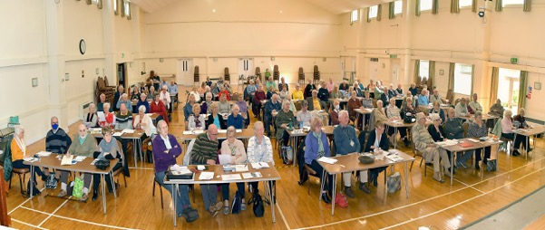

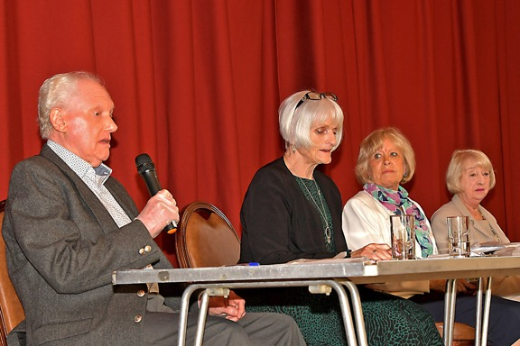
A motion was passed, but everyone tried to ignore it.

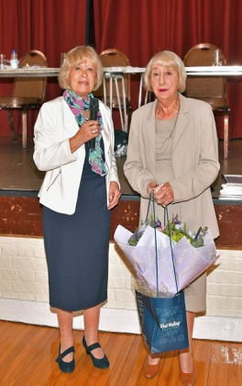
Flowers were given to outgoing President Shirley Skinner.

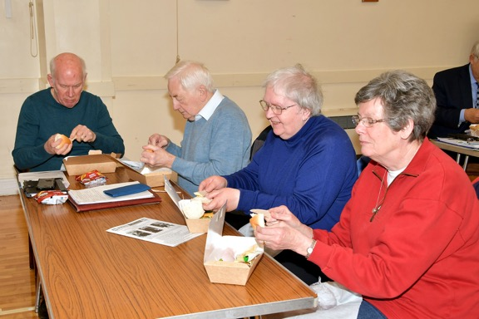
The Mini Pork pie went down well…

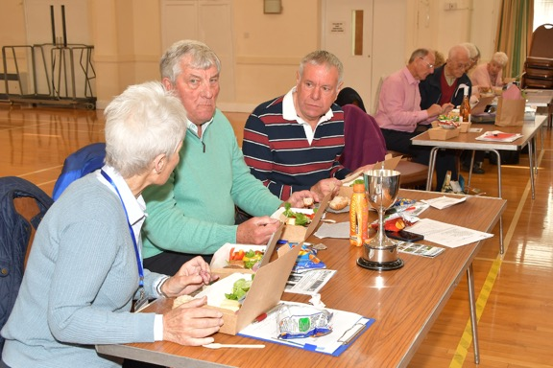
Slab of mature cheddar, seeded bread roll, pat of real butter (not melted), Ardennes pate, bag of crisps, Tea and Coffee (with optional Woods Rum 57% vol.), squash for drivers. Cake! Sacher Torte, Viennese Whirls, Vanilla Slices, Black Forest Gateaux, Crepe Suzette, followed by Fire Brigade.

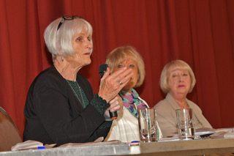
Heated debates no one could remember…
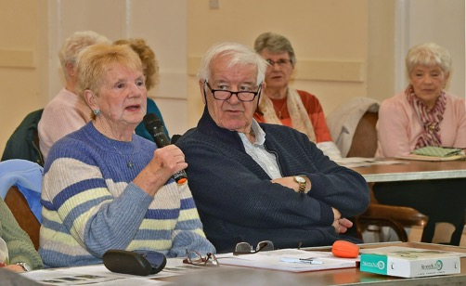
Pearls of wisdom…
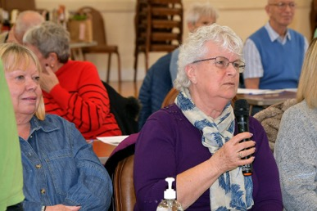
…that none could understand

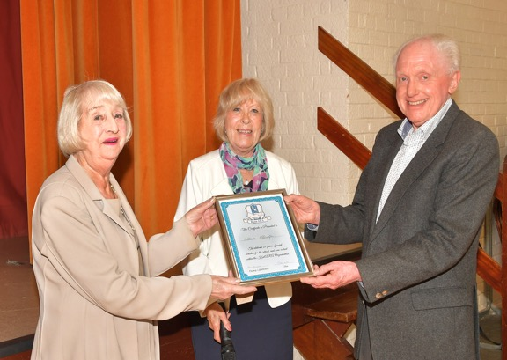
Certificate for endurance…

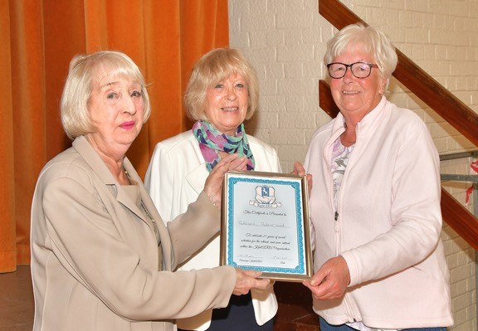
Certificate for best blond hairdo…

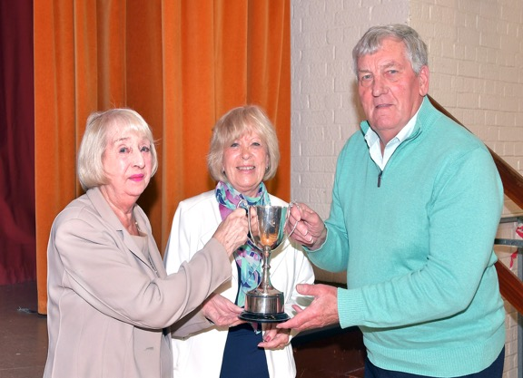
…Cup of good cheer (plated)

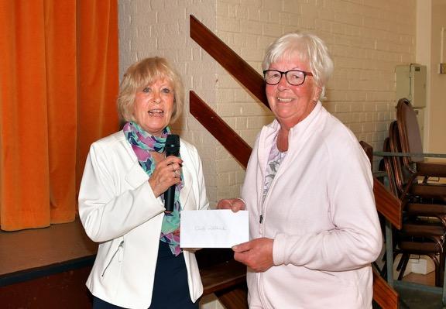
You Again! Jammy raffle prize winner...

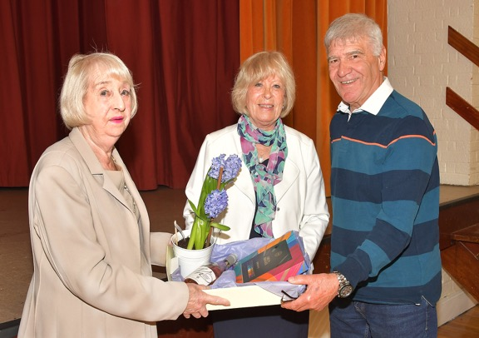
Your guess is as good as mine…

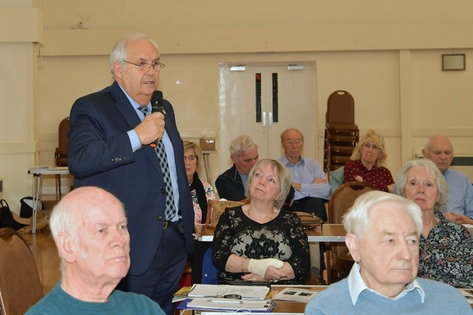
Common sense from Frank Stocks.
THE END.

What a Summer!
Photographs from Graham Pover the KentAra ‘Snapper’.

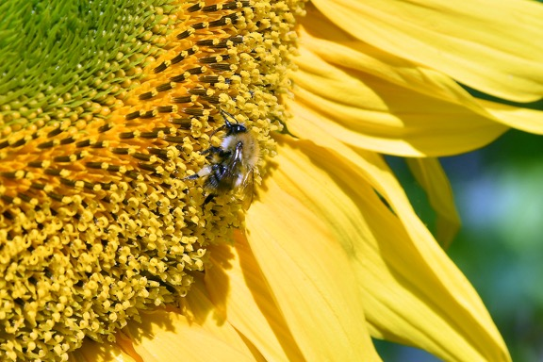
Sunflower with Bee

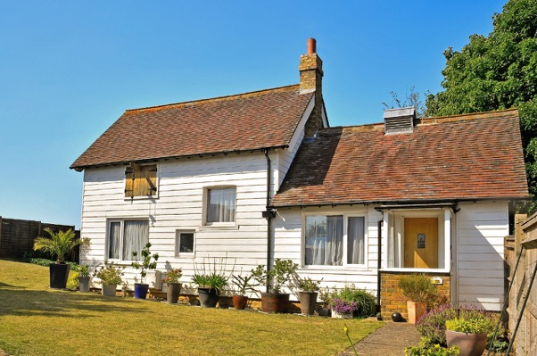
A Traditional Kent Weatherboard House

gpoverphotoraphy@btinternet.com

