Kent Active Part 2 Issue 88

KentARA Race Afternoon at ‘Ditton Downs’

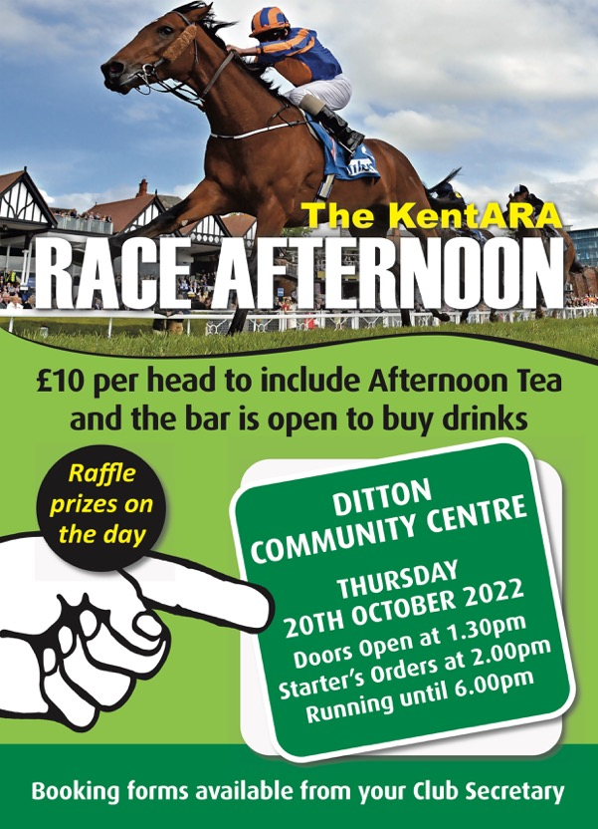
Back a winner at Race Afternoon

The KentARA Tea Dance
A Montage
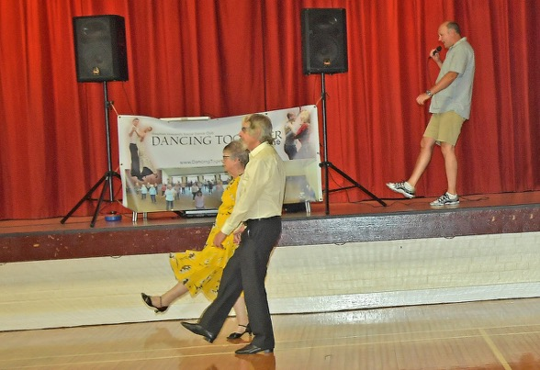

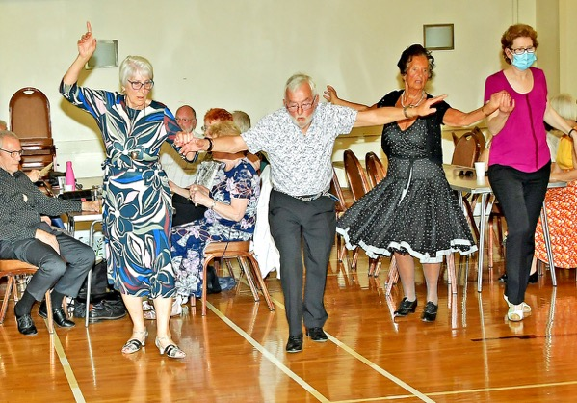

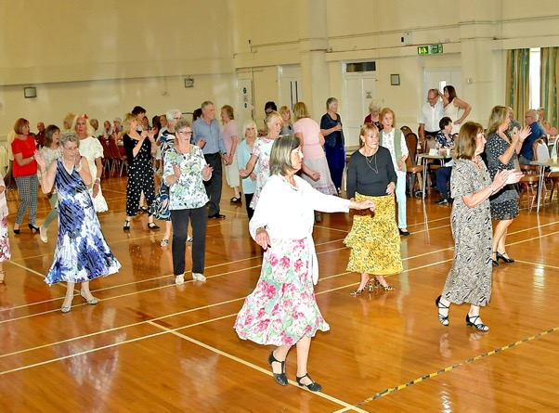

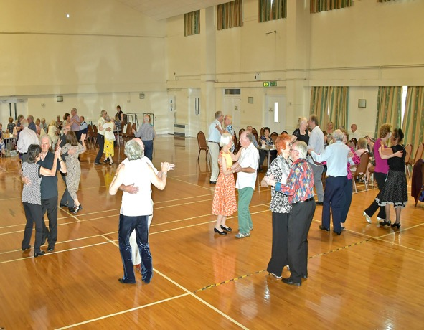

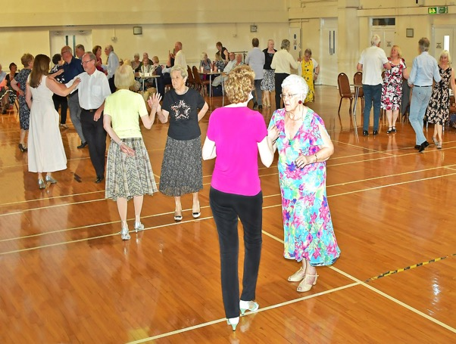

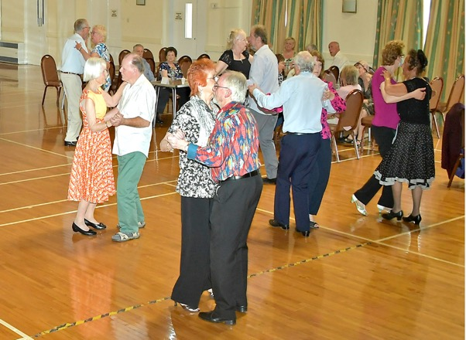

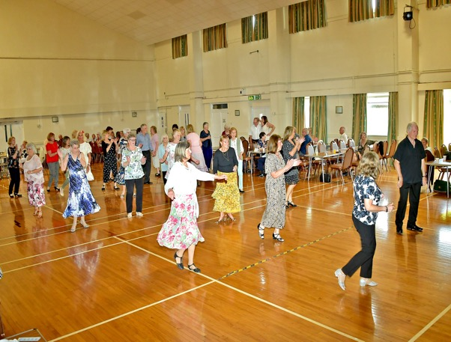

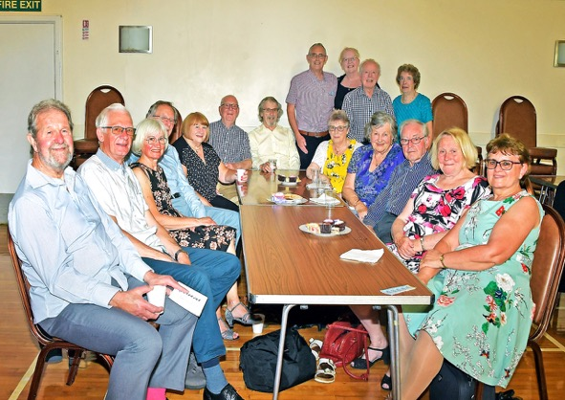

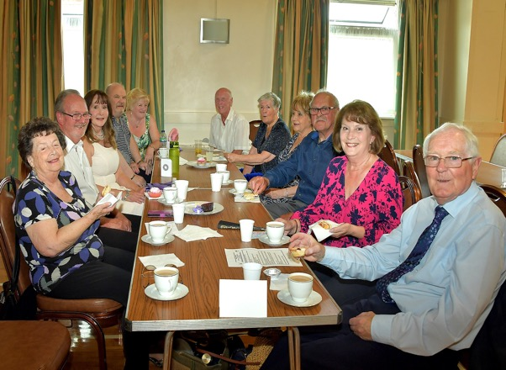

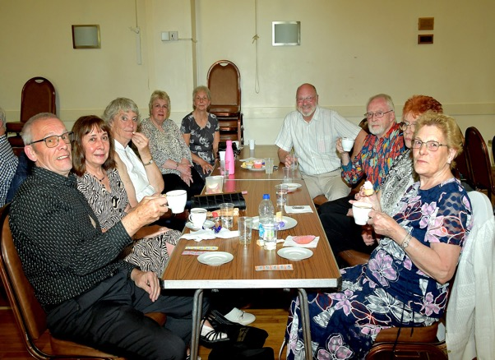

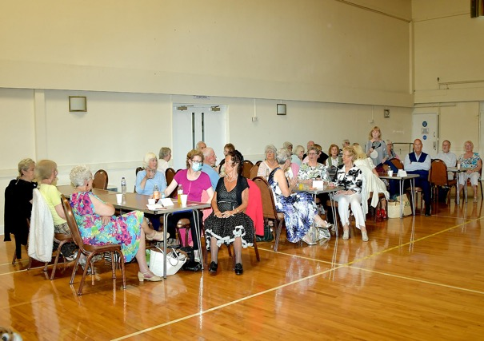

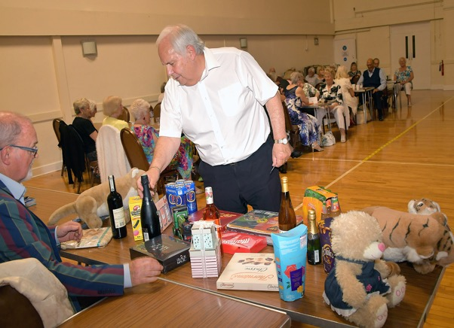

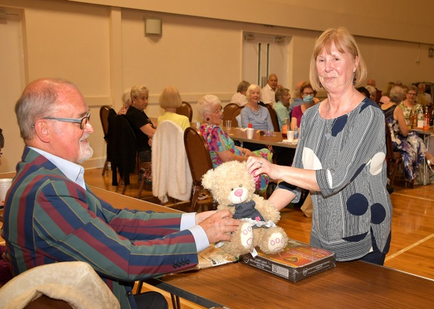

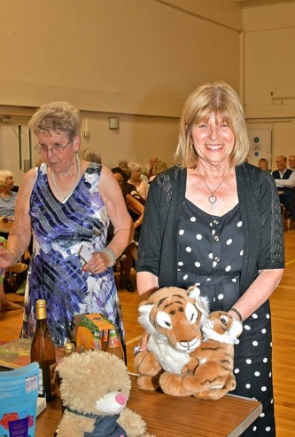

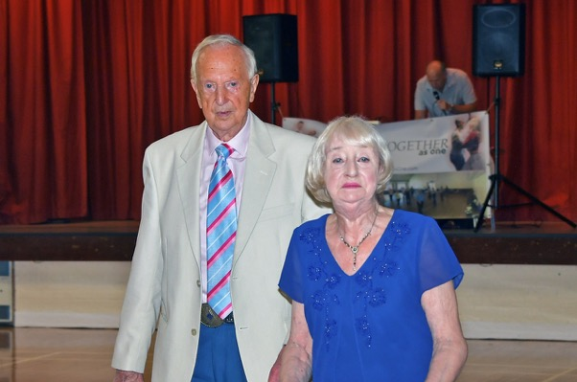
The KentARA Line Dance Empresario, Geraldo Benito, with Shirley Bombshell

Kentara Tea Dance
At Dittons Community Centre, Ditton ME20 6AH

They came from far and near, including a coach full from Ramsgate, and they all got what they came for; a great afternoon of dancing and fun, that made it the best Tea Dance we have ever had!

Our MC, Stephen Howard planned all our favourite dances, whether it was line, ballroom or sequence, with everybody seeming to join in - they must have been thirsty as our helpers never stopped filling the cold drink jugs all afternoon. During the interval tea and coffee were served with a lovely selection of cakes, followed by a fantastic raffle - what could be better.

If you were unable to make this one, make sure you are at our next Tea Dance on Friday 11th of November, it is just too good to miss.

Gerald Benham
Organizer
Tel. 01732 870 715

