**../../../../../../../Pictures/ARA/Pics/ARA%20LOGO/ARA%20master%20shield%20lo GHENT ACTIVE ../../../../../../../Pictures/ARA/Pics/ARA%20LOGO/ARA%20master%20shield%20lo**

**THE NEWSLETTER OF KENT ACTIVE RETIREMENT ASSOCIATION MEMBERS**

**STUCK AND SELF-ISOLATING IN A POST BREXIT BELGUIM**

**Volume Seven January 2021 No. Seventy 9**

***Circulation: Who’s Counting?***

***“Do not think of retirement as someone closing a door on you.***

***Think of it as being locked in a small hotel room somewhere in Europe.”***

**Anne Twerp** (Foreign Despondent for the Association)

**A Day in Lockdown.**

**Here we are in Lockdown once again,**

**And every day is much the same.**

**Eating it seems punctuates our day**

**Helping to while the hours away.**

**It’s up for breakfast between eight and nine**

**This sees us through to coffee time.**

**Then onwards to lunch between one and two**

**What’s for dinner then we’ll review.**

**A cup of tea later to keep us hydrated**

**Then later to dinner to keep us both sated.**

**Of course we go for a walk in between,**

**For doing our exercise must be seen,**

**As we smile, and wave but keep our distance,**

**To prove to our neighbours, we’re still in existence!**

**Occasional phone calls with family, and friends.**

**A few hours of TV until the day ends.**

**Then off to bed to read books for a while,**

**And another day over we reflect with a smile.**

**So this is how our days are spent,**

**And from me the occasional poetic lament.**

**‘Til we’ve all had the vaccine to keep COVID away,**

**For the foreseeable future this is our typical day.**

**From Christine Kent of Hempstara – Hempstead.**

**MERRY NEW YEAR**

***From the Orifices of the KentARA Committee***

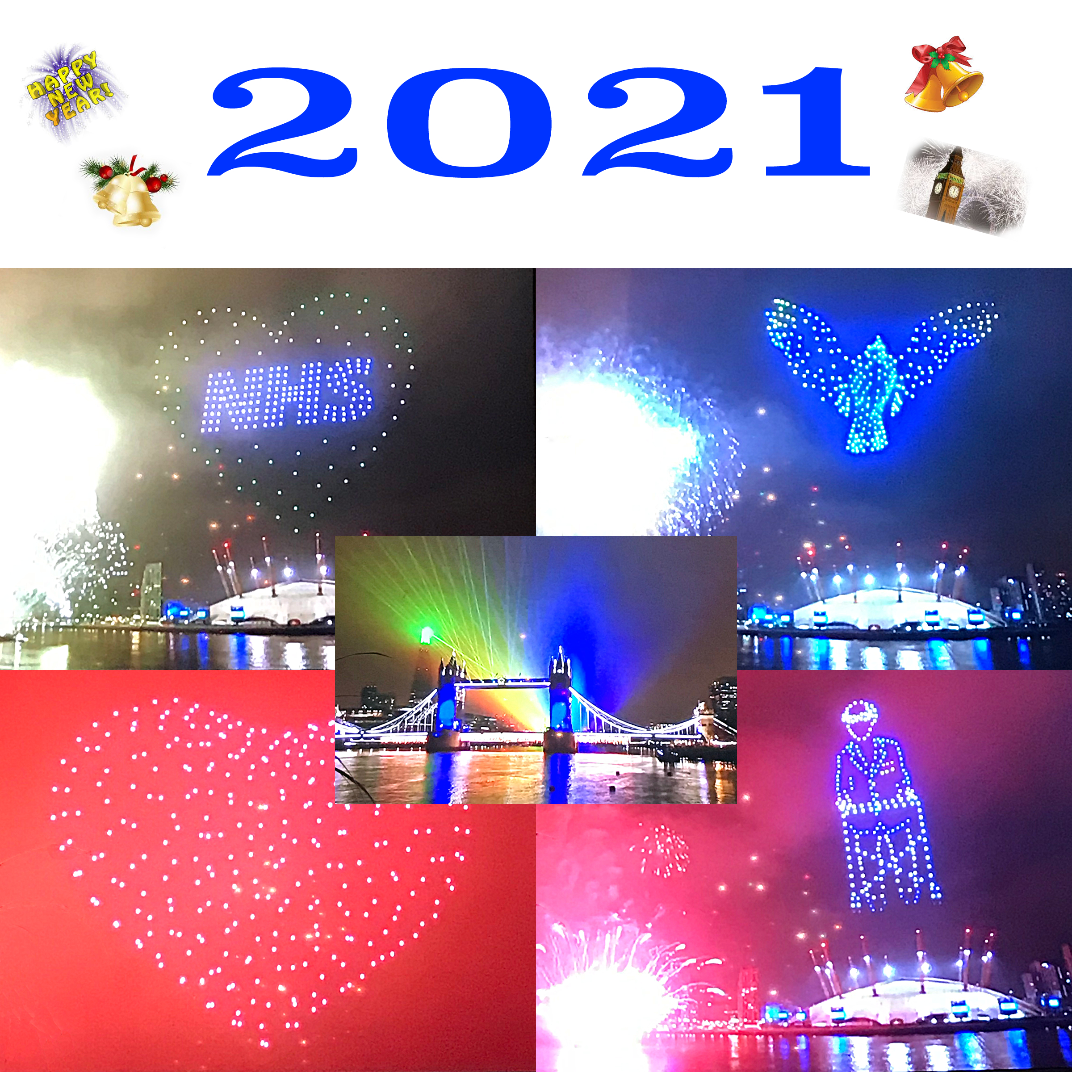

**Photography by Graham Pover. Graham can be contacted at** [**gpoverphotography@btinternet.com**](mailto:gpoverphotography@btinternet.com)

***Give Covid the Rocket in 2021***

**A Message from our Chairlady Joan Rhodes**

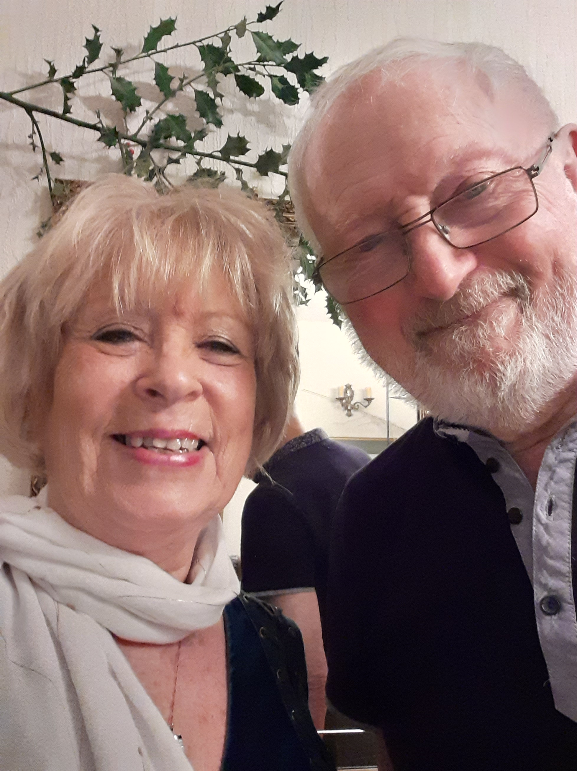

***A Sideways look at 2021 from Joan Rhodes our KentARA Chairlady, and Father Christmas.***

**Dear Kentara Members,**

**Wishing you all a very Happy & Healthy New Year, let’s hope it’s better than last Year.**

**I hope you all had a good Christmas, and are keeping well.**

**I am sure once we have our Vaccine, we will slowly start to get back to some sort of normality. In the meantime take care, wear your face masks, and wash hands regularly.**

**The good news is we have transferred our KentARA Cruise with Fred Olsen going to the Scandinavian Fjords from 22nd May to Saturday 24th July 2021, you can transfer direct with Fred Olsen at no extra cost, and hopefully the same cabin.**

**If you have any queries do get in touch with me. This is something we can look forward to, and the weather I am sure will be good.**

**Take care and keep safe, we will soon be able to be back together.**

**Love & Best Wishes,**

**Joan, and all the committee members of KentARA.**

**01732 844 953 mobile 0777 623 6341**

**From the Sinclair ZX80 Computer**

**of the Kent Active Newsletter Editor Mr. Wishy Washy**

**Hello Everyone.**

**After the "stop - go" of the later part of last year, and publishing the Risk Assessments which were collated by our Secretary, and a member who was an ex-Health and Safety officer, on our website in August 2020, with a view of starting our activities from the 8th October 2020, with due regard to social distancing, sanitizing, and the one-way system in use whilst playing Soft Tennis, Table Tennis, and when undertaking the Art Class.**

**The outside activities, were somewhat simpler, Village Walks were reduced to groups of 6, gathering in groups, with staggered start times in the Village Hall Car Park.**

**Our Boules, were separate groups of only 6 with a strict start / finishing time, allowing each group 50 minutes playing time, more than ample time, for 3 players on each team, who afterwards, were more than ready for a Coffee or Tea in the Clubhouse. I'm pleased to say everything worked like clockwork, especially as we were meeting up again!**

**Sadly, after 3 weeks, Boris decided to put us back on another Lockdown on 5th November 2020, best laid plans of men etc. We have all experienced a very different Christmas, and New Year, but as they say, "every cloud has silver lining",**

**and suddenly there is "Light at the end of the Tunnel", and not a Train coming from the opposite direction!!**

**A vaccine is being rolled out, and for once- we of a certain age, are being given priority, some consolation for losing our free TV licence perhaps? By the time this is published, I shall have had my first Injection, much to my relief!!**

***From Wishy Washy - Editor Kent Active Newsletter***

**Short Stories from KentARA Members**

***From Linda.***

**Many moons ago on a holiday to Protaras in Cyprus, I was enjoying a dip in the ocean. However, as I was swimming about, the straps of my costume kept slipping halfway down my arms which was really annoying me.**

**Taking a look around I saw that I was quite far from any other swimmer so I slipped the straps off completely and floated free as it were!**

**I was thoroughly enjoying the peace and freedom as I lazily swam around, safe in the knowledge that there was no one in the vicinity to see me half naked floating in the sea.**

**Suddenly beneath the water I saw a dark shape swim alongside me. Imagine then my horror when the local scuba diving school surfaced about three feet in front of me!!!**

***From Rosemary.***

**A story from my past.**

**Many years ago I was working in Sierra Leone. I was taking a baby Clinic out into the local countryside.**

**This day I had with me an interpreter and we were going to a village,**

**Going out of the village where we lived, I had to drive the land rover along a single tarmacked holed road.**

**Ahead of me a flock of sheep were sprawled across the road. I very carefully drove through them, and went on my way.**

**When I returned later in the day I was greeted by a local man telling me I had knocked and killed one of these sheep. I was horrified, and I was told I would be wanted by the police.**

**As you can imagine I had a bad night.**

**Later the next day The same man came to me and said that there was not a case because someone had eaten the evidence!**

**If you have a similar bone crunching story, or a rib tickling tale, or some side splitting howler of a happenstance then email the Newsletter editor ‘Wishy Washy’ at:** [**togthedog@btinternet.com**](javascript:;)



**What ARA?**

**If you remember the last Newsletter, the answer was UpARA (Upchurch).**

**This Months, ‘What Ara’ is :-**

**An ARA which is situated between the County Town and the well known Spa Town, famous for its Pantiles.**

**Our ARA is right in the heart of the Hop Country, it is close a very popular attraction "The Hop Farm" which has the highest number of Oast Houses on one site, and used to be a Holiday Home for the Whitbread Shire Horses.**

**I personally have taken a Hot Air Balloon trip from this attraction, and flew fairly close to this ARA's meeting place, St Andrews Hall at St Andrews Church; in(as I remember it the Village.**

**How many ARA members can name the majority of different ARA's in our county?**

**This month’s ARA will be revealed in the next issue.**

**Stay safe, look forward to your vaccinations, and the Spring.**

***Wishy Washy***

***Editor Kent Active Newsletter***