^{The} KENT ACTIVE CHRISTMAS ^{‘ROUND ROBIN’ 2022}
Father Christmas
Special Delivery
25th December
News of the Cruise
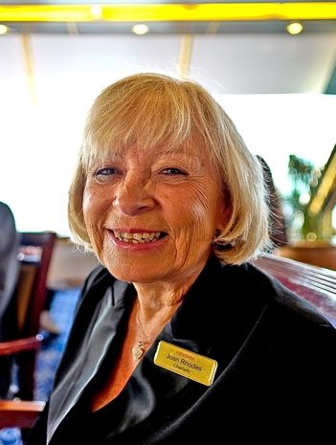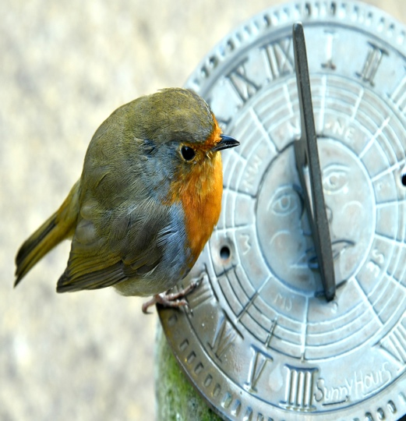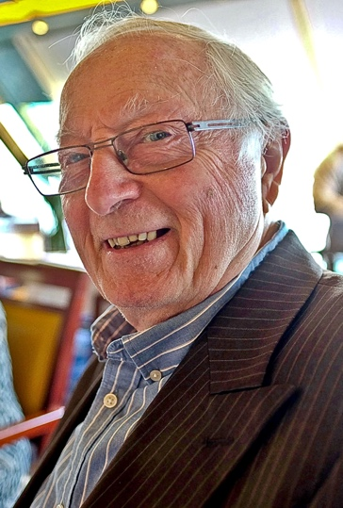
Christmas Bird No.1 Christmas Bird No. 2 Who’s a pretty boy then?
Dear Members,
On the 14th of September 2022 after two cancellations, and a three year wait, we finally set off for the Norwegian Fjords on Fred Olsen’s beautiful ‘Bolette’ Cruise liner. This came as a hell of a shock to some of our members who had forgotten the destination, and thought they were going for a cruise on the Norfolk Broads on a barge. Gratefully they had already paid, and were glad of the upgrade.
The sea was a bit rough for the first day and a half, but then the sun came out, and made the scenery even more wonderful, and was glorious for the remainder of our trip.
The crew and staff on board were very caring, and professional, there was always something to do if you wished during the day. In the evenings we were treated to shows of a West End quality.
The photos here, will be available to view in person if you wish to have one, at the KentAra Christmas Concert at Ditton on Thursday 8th December, where the Military Wives Choir will be singing, along with two other different entertainers, the Barbara Snow & Richard Sutton Duo Sax Show, and Mike ‘Mr Smooth’ Harris, with Tea, Coffee and Biscuits, and open bar.
The cruise was a great success, everyone got on famously, and thoroughly enjoyed themselves. I thank you for your great company, and for supporting us at KentARA.
Take care of one another. Merry Christmas and Happy New Year.
Kind Regards, and much love, Joan Rhodes. KentARA Chairlady.
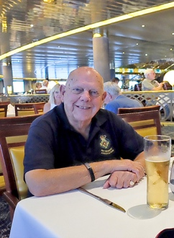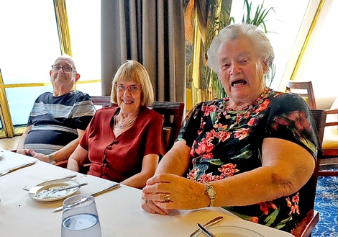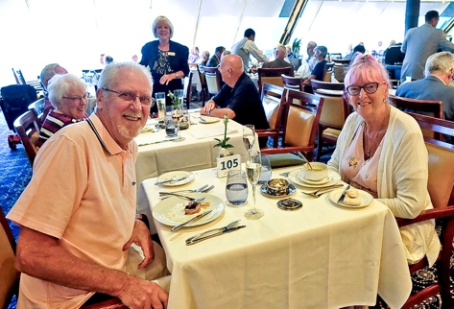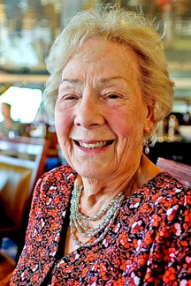
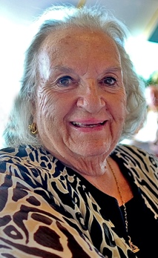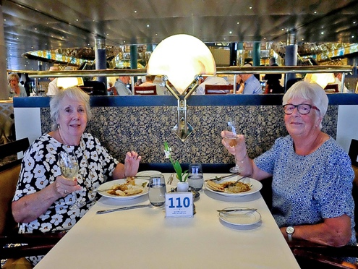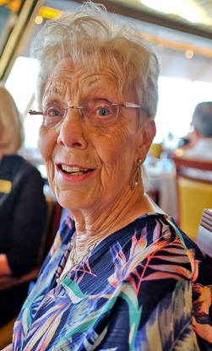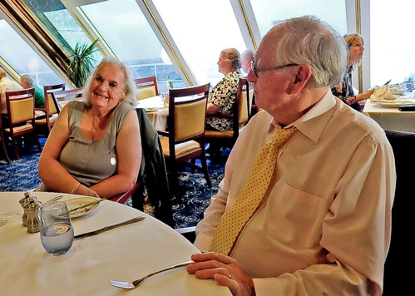

DATES FOR THE DIARY
2023
- ^{The} KentARA Quiz
Wednesday 22nd March 2023. 1.30pm – 5pm
Ditton Community Centre.

- KentARA AGM at Ditton.
Thursday 6th April 2023. 9.30am – 3pm
Ditton Community Centre.

- KentARA Tea Dance – ‘Just too good to miss’…
Monday 22nd May 2023. 1.30pm – 5pm
Ditton Community Centre / Ballroom 01732 870 715

- Short Mat Bowls
Thursday 24th August 2023. 8.30 am – 4.30pm
Ditton Community Centre.

- Race Afternoon at ‘Ditton Downs’, with Afternoon Tea
Friday 20th October 2023. 1.30pm - 5pm
Ditton Community Centre.

- Tea Dance
Thursday 3rd November 2023. 1.30pm – 5pm
Ditton Community Centre / Ballroom 01732 870 715

- KentARA Christmas Concert
Thursday 7th December 2023. 1.30pm – 6pm
Ditton Community Centre

&

- Line Dancing EVERY MONDAY Afternoon
Larkfield Village Hall. 12 noon to 3.45pm
All Levels. Enquiries, Gerald Benham 01732 870 715

