**../../../../../../../Pictures/ARA/Pics/ARA%20LOGO/ARA%20master%20shield%20loKENT ACTIVE ../../../../../../../Pictures/ARA/Pics/ARA%20LOGO/ARA%20master%20shield%20lo**

**THE NEWSLETTER OF KENT ACTIVE RETIREMENT ASSOCIATION**

**Volume: Seven May 2021 No. 81**

***“Do not think of retirement as someone closing a door on a bright and crowded street.***

***Think of it as someone opening the door to a beckoning and uncluttered world.”***

**John Hardiman** *(Founder of the Association)*

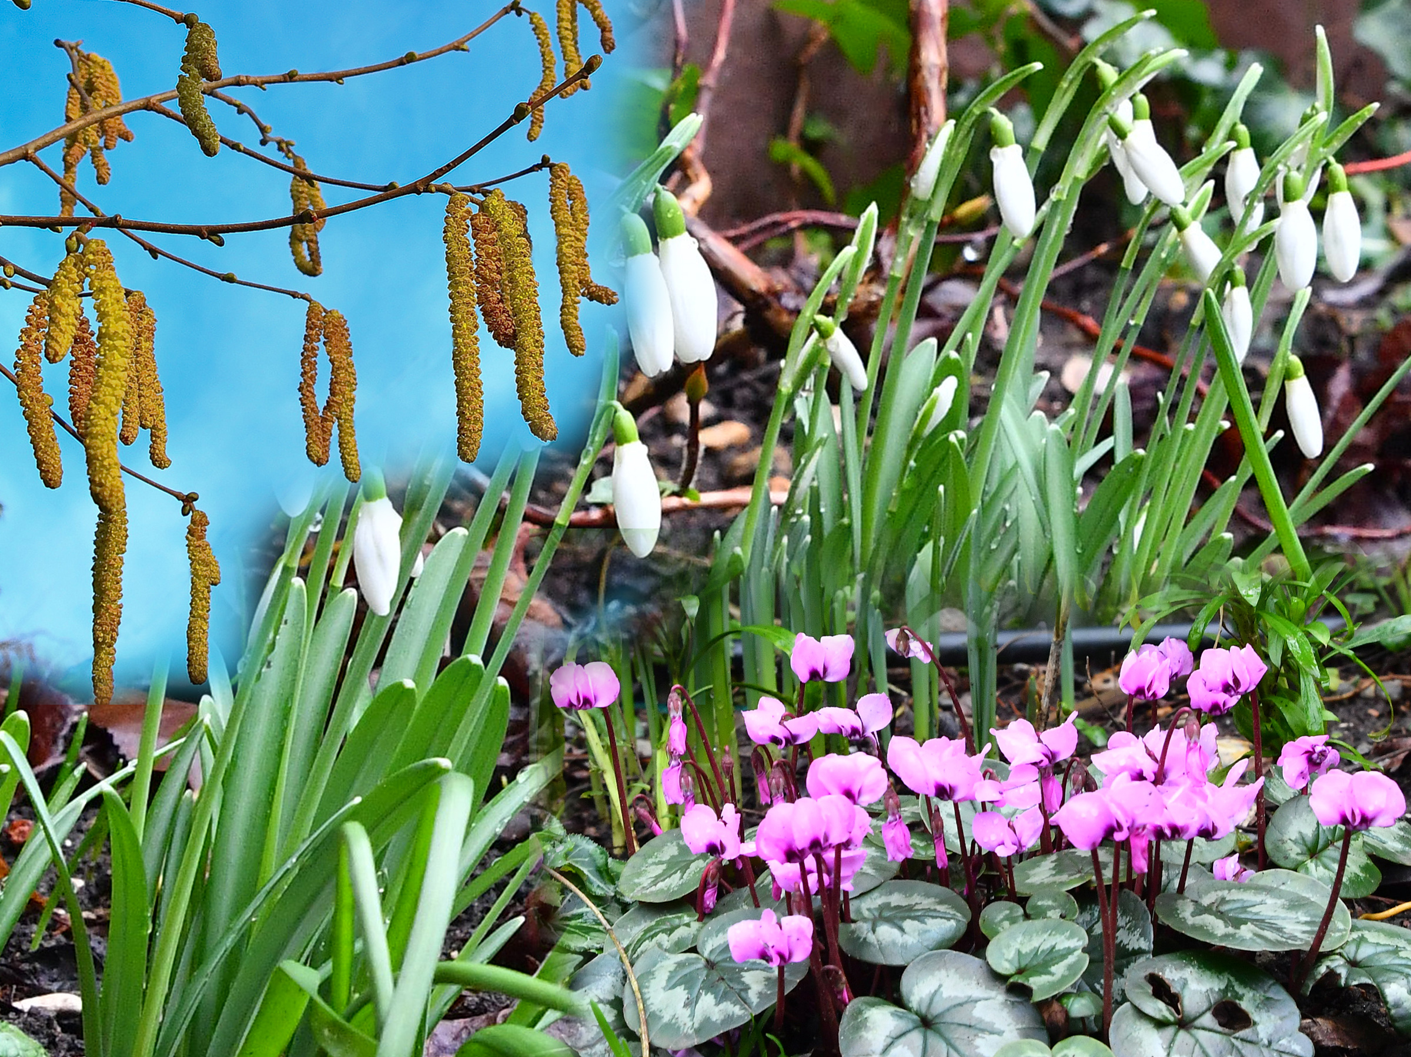

**‘Little Preston’. Photograph by Graham Pover. Graham can be contacted at** [**gpoverphotography@btinternet.com**](mailto:gpoverphotography@btinternet.com)

**A Message from our Chairlady Joan Rhodes**

**Hello KentARA Clubs!**

**We do hope you are all keeping safe, and well.**

**I expect most of you have had your second vaccine now, and we are all looking forward to eventually coming out of Lockdown with care after 21st June. Some Clubs using the Covid-19 Self-Test Rapid Antigen Kits, (to check every member has tested ‘Negative’), are hoping to resume small social meetings with face masks, and of course ‘Social Distancing’, cleaning chairs, surfaces, and hands, with members bringing their own refreshments, cutlery, and cups etc.**

**We are not exactly sure how many people are allowed to mix at the moment, so look at the government website to make sure you are up to date.** [**https://www.gov.uk/coronavirus**](https://www.gov.uk/coronavirus)

**BearARA have agreed to organise ‘The John Hardiman KentARA Short Mat Bowls Competition’ on Tuesday 28th September 2021. If you are interested please send forms to Barbara & Bob Abnett, via the BearARA Club Secretary at** [**pam.bland@outlook.com**](mailto:pam.bland@outlook.com)

**It will depend on how many are interested, as to whether this event will go ahead.**

**We have booked Ditton Community Centre for the ‘Race Afternoon’ for Friday 22nd October 2021 but again we will need to have enough interest to go ahead. Let me know.** [**rhodjo@aol.com**](mailto:rhodjo@aol.com)

**The Rochester Cathedral Thanksgiving Service planned for this October 2021 has had to be postponed to October 2022, as the Cathedral is now being used as a Covid Test Centre until further notice.**

**The KentARA Christmas Concert is planned for on 10th December 2021, but once again this will depend on interest shown.**

**Also please come forward if you would like to arrange the Ten Bowling Competition at Hollywood Bowl this November 2021.**

**It is so great that we can now start to plan again, and get back to some form of normality with care.**

**Of course this all depends on the Covid numbers not going up, and Government advice.**

**Keep safe and well, hope to see you soon.**

**Love & Best Wishes, Joan. 01732 844 953**

**From the Chaise-Longue of the Kent Active Newsletter Editor,**

**Mr. Wishy Washy**

**Hello Everyone.**

***From Wishy Washy - Editor Kent Active Newsletter***

***Joke of the Month:* Politician: One who shakes your hand before an election, and your confidence afterwards.**

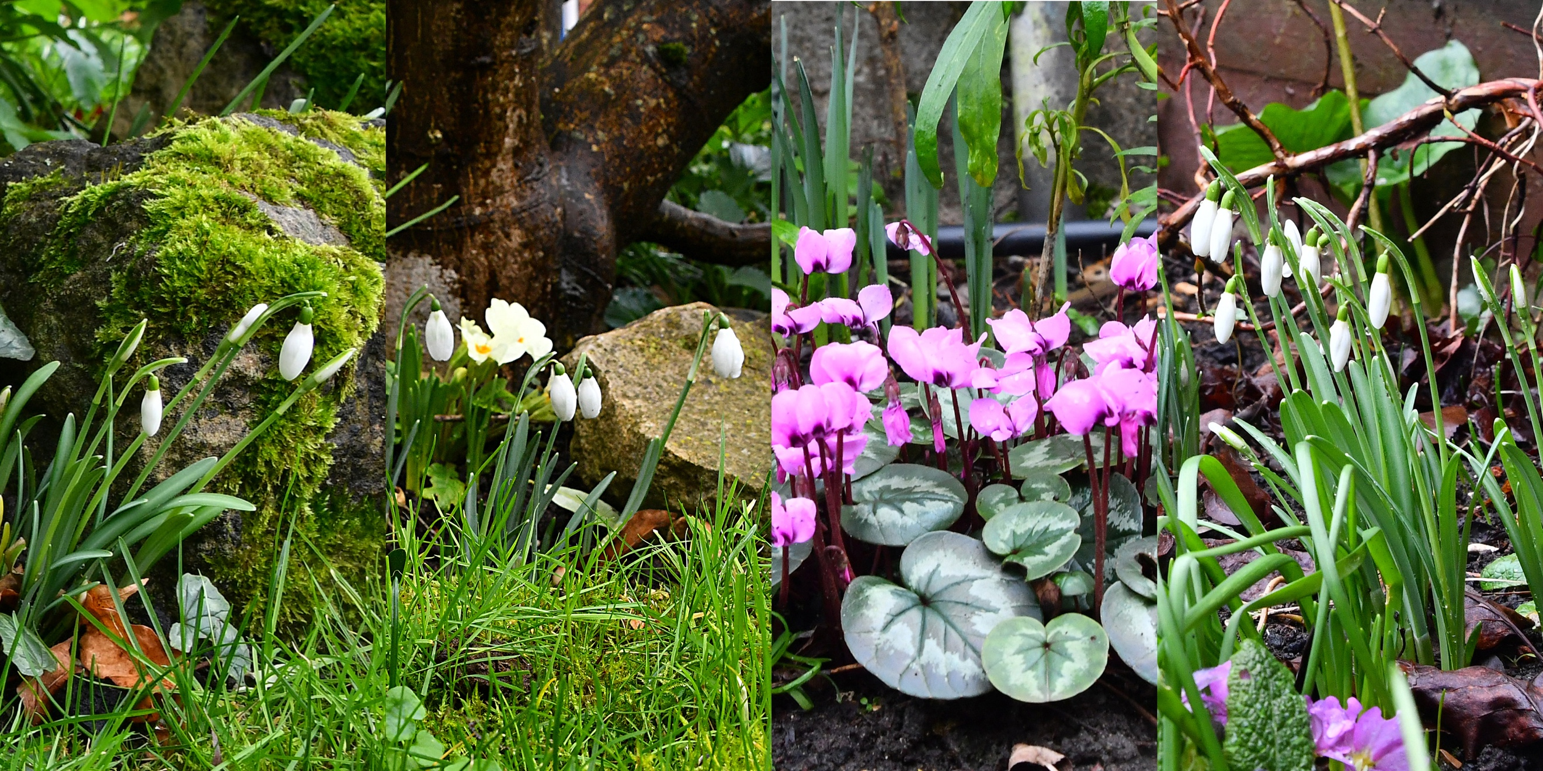

**Photograph by Graham Pover. Graham can be contacted at** [**gpoverphotography@btinternet.com**](mailto:gpoverphotography@btinternet.com)

**ShadARA – Charity Triumph at Second Hartley District ARA**

**As most of our members are aware Wendy is a very talented card maker and seamstress, her cards are regularly for sale at our meetings.  During lockdown Wendy has been very busy with her card making, and with her sewing skills, producing face masks - they have been much in demand due to Covid-19.  Wendy raises funds from the sale of these items for our SHADARA charity ‘Altzehimers’. Wendy has raised over a staggering £500.00, a fantastic effort.  The money has been passed to our Treasurer Brian, and he is raising a cheque to send to the Charity.**

***‘Pinch of Salt’* Short Stories from *‘Porky Bacon’* of TrottiscliffeARA**

***From Cora of Up le CreekARA***

**I was out for my usual walk along the Saxon Shoreline, when I took quite queer. The Air Ambulance was called, but by the time they arrived; much to my embarrassment, I felt quite recovered. So I said that I had taken a turn for the worse, after waking the long way around to my Chemist for some aspirins. So they winched me aboard the helicopter, and whisked me off to my local Chemist, where after landing on the shops flat roof, the pilot entered the building via the skylight, collected my pills, and returning to his chopper, flew me home, and slung shot me throw the front door.**

***From Stanley of WallopARA***

**I used to commute to London every day for some 20 years. It was sometime in the late 50’s that I remember oversleeping, and missing my breakfast, in order to catch the train. Once on board, the conductor inspected my ticket, and I mentioned that I had missed my breakfast, and could he possibly rustle me up a couple of poached eggs on fried bread, with bacon, tomato, and a cup of tea – milk, two sugars. Within 15 minutes he returned with my order. The Royal Trains Kitchen Carriage had been attached to the rear of the commuter train, and was being relocated.**

***From Lillian of Bedlam BottomARA***

**Mathematics was my weak subject, but I really needed to get a top ‘O’ level pass in order to get a good job, and have a successful career in a male dominated world. I had barely got a wink of sleep the previous night revising, and worrying. As the exam paper was placed on my table, I noticed a slip of paper between its sheets. When I turned it over, there was a small piece of graph paper which had the typed answers of ever question on it, and the brief statement that if I used them, I would receive an ‘A’ grade pass. Subsequently, I spent 40 years in accountancy, with a calculator.**

**If you have a similar bone crunching story, or a rib tickling tale, or some side splitting howler of a happenstance, then email the Newsletter editor ‘Wishy Washy’ at:** [**togthedog@btinternet.com**](javascript:;)



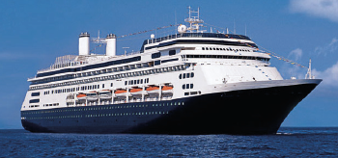 **Message in a Bolette from Ol’ Fred **

**The FOCL 2022 Launch Campaign Offer has now been extended until 31st May 2021.**

**Free all-inclusive drinks package, or £100 per person, free on board spend credit.**

**../../../../../../../Pictures/ARA/Pics/ARA%20LOGO/ARA%20master%20shield%20lo KENT CHIVE ../../../../../../../Pictures/ARA/Pics/ARA%20LOGO/ARA%20master%20shield%20lo**

**THE ALTERNATIVE NEWSLETTER OF KENTARA ALLIUM LOVERS**

**Volume: Seven May 2021 No. 81**

***Circulation: By April Fuller***

***“Eat an Onion a day to keep Covid away – and everyone else.”***

**Charlotte Leek (Onion Grower – *Pickled* )**



**‘Know Your Onions’. Photograph’s by Graham Pover. Graham can be contacted at** [**gpoverphotography@btinternet.com**](mailto:gpoverphotography@btinternet.com)

**A Message from the .hair**

**Dear Kentara Members,**

**One of the lesser known symptoms of ‘Coviditis’ is the loss of a sense of humour. As if it were not bad enough to lose the taste of marmalade on your toast, the added loss of a sense of humour for many members, could not come at a worse time. As a remedy the team of editorial comedians at KentARA have produced the *‘Alternative’* Kent Active as an antidote against any loss of lauyghter. As you can see it is added upside down to the newsletter, so you don’t have to read it.**

**Naturally this document can be edited freely, and you can choose to forward it in any censored Orwellian form you choose. Also we would like to once again extend an invitation for you to join ‘The Ministry of Information’ here, where you can choose to join either our ‘Witty WritingTeam’, or for the more serious minded, the ‘Joyless Scribbling Team’. The choice is yours.**

**For the ‘Joyless Scribbling Team’ please contact:** [**joyless@miseryguts.com**](mailto:joyless@miseryguts.com)

**Or to join the ‘Witty Writing Team’ please contact:** [**togthedog@btinternet.com**](javascript:;)

**If bad smelling, and poor grammer get your back up, than please be aware that Wishy Washy the Editor can’t read, Woody Church the poof reader is dyslexic, and Aramis Scribe has pebble glasses, dribbles, and is mad as two bats with rabies on a good day; so under the circumstances we do pretty well to get anything out. If, however you can read, are not dyslexic, can see without binoculars, and of course are sane, then you are most welcome to help us out, anytime.**

**A Story of the First Jab**

**The authoress of this article wishes to remain anonymous.**

***“When I said I was an ‘Anti-Vaccer’, all I meant was I don’t like hoovering.”***

**This is a joke, although I am admittedly a sceptic when it comes to the benefits of a ‘clean house’, after all you have to keep your immune system on its toes.**

**On arrival at the surgery I declined to sit down as you don’t know the condition of the people who sat there before you. The nurse giving the injection was barely 5ft tall, and with me being some 6 foot, she practically needed a step ladder to get to my upper arm, and I risked getting my ear pieced by accident. So I bent my arthritic knees, so she could stretch to arm pit level, and then she harpooned me good, and proper. Honestly, the pain was no worse than child birth.**

**I was then asked to wait 5 minutes in case I showed signs of metamorphosing into an old bat, although my husband said that would be an improvement.**

**I asked one of the volunteers if the first jab would ease my urge to roost upside down in the attic, and she said that it would, but that any passing flying insect should still watch their back.**

**A round sticker was placed on my forehead which read, ‘I’ve been Vaccinated’, and I sidled out of the door along the one-way system feeling quite chuffed, grateful, and relieved that we have a NHS, and that it works efficiently. I was also proud of our scientists. Then I began to feel like I wanted to boast, and ring everyone I knew, and tell them that I had just received my first jab - much as they had done to me, some weeks before I had even had the first sniff of my mine. It was not a realisation I was proud of, but at least I was aware of it.**

**Twelve hours later, I had some side effects. A huge evacuation, chills, sweats, a tingling tip of the nose, fingers that felt like fat sausages, and then thin chipolatas, dizziness, breathlessness, until eventually I remembered I was told at the surgery that I could take paracetamol for it all, which I did, and felt almost immediately better, and gratefully slept, to wake very much over the worst of it.**

**A full two days later a jolly decent bruise from the injection came up for about a day, which slowly subsided into an itch that wanted a good scratch.**

**At least I knew that my immune system had woken up. I was pleased, and very much reassured to know that it was still there to be stirred into action.**

**I don’t believe in half measures, and I will certainly return for my second jab, (although unlike some of my friends who got their first jabs in the early days, and automatically received the date for their second jab), I will await to be re-contacted by my doctor, and surgery for mine.**

**If a third variant booster jab was offered later, I gladly would take it too. I was glad for the Pneumonia jab some five years ago, and half expect to get another in the coming years. They are no substitutes for the annual flu jab, or the Covid vaccines, just as vitamins tablets are no substitute for a good diet, I nevertheless want all the odds in my favour, and so I take vitamin D tablets, because I see so little sun, and a Zinc supplement, because it has been shown to be good for the immune system.**